Karthikeyan Rajamani

UTA ID: 1001267157

CSE5345

Lab2-OPNET

## 1.1

Node1: Video traffic

Node :3-5 Background Traffic

Interarrival time-0.1

Packet size:500 Bytes

Network Toplogy:

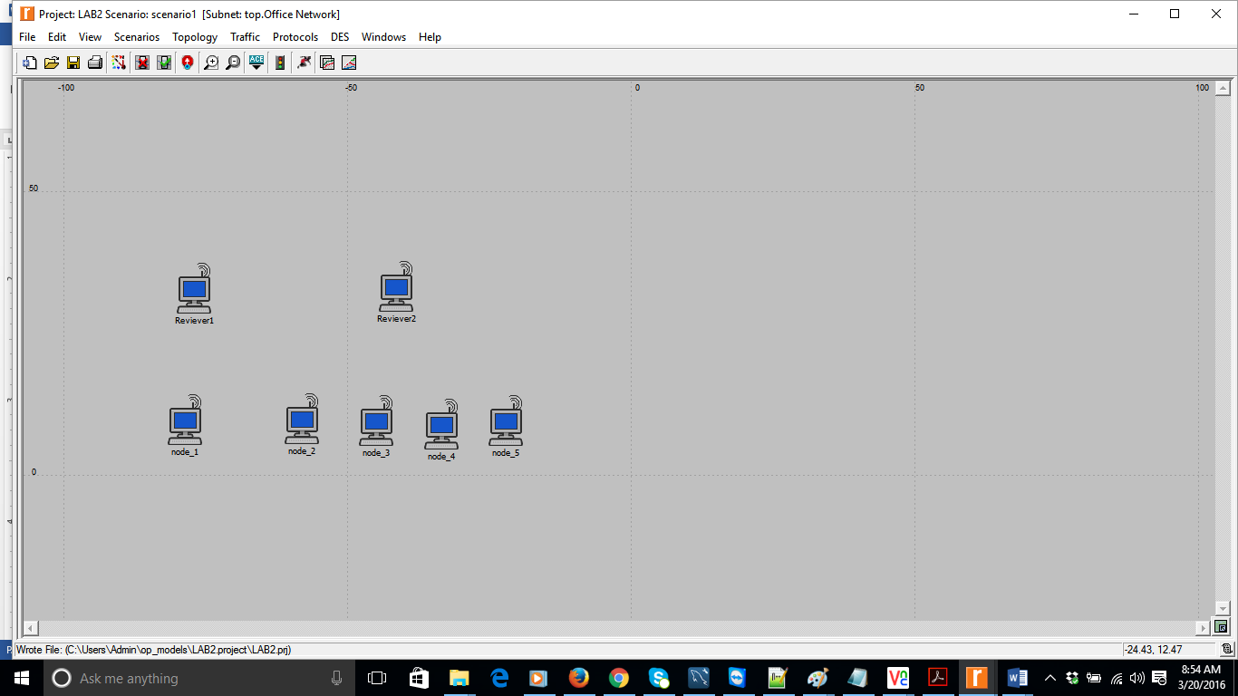

Reviever1 configuration:

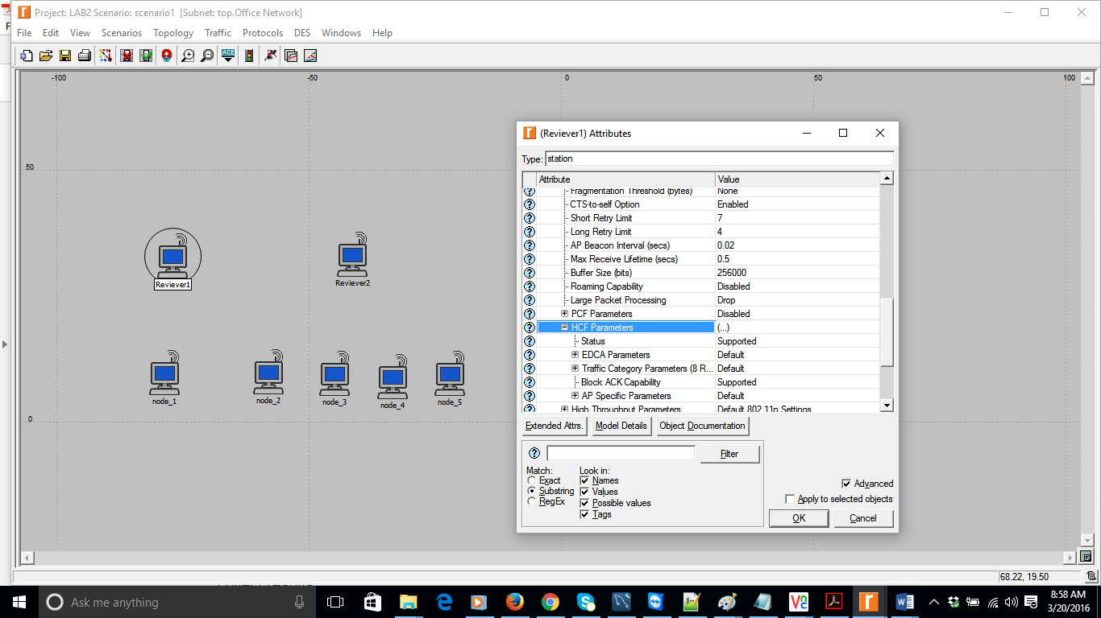

Node1 Configuration:

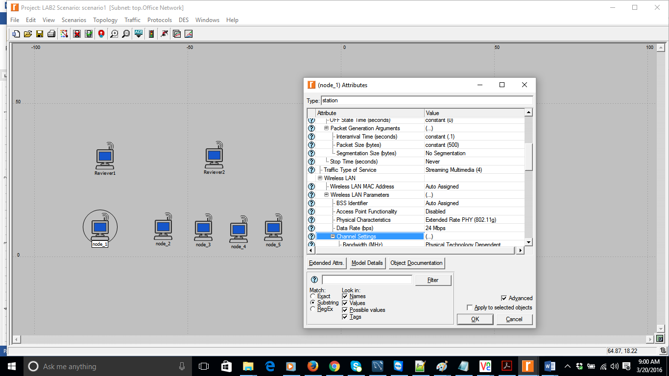

Configuration for Node 2, 3, 4 & 5

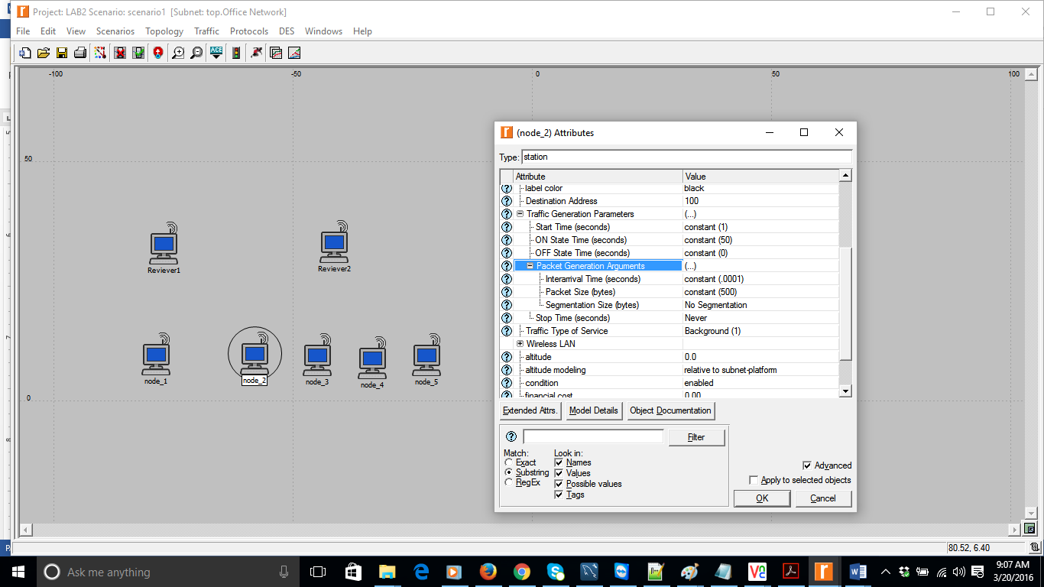

Throughput for Node1 at Receiving Station1 streaming video traffic:

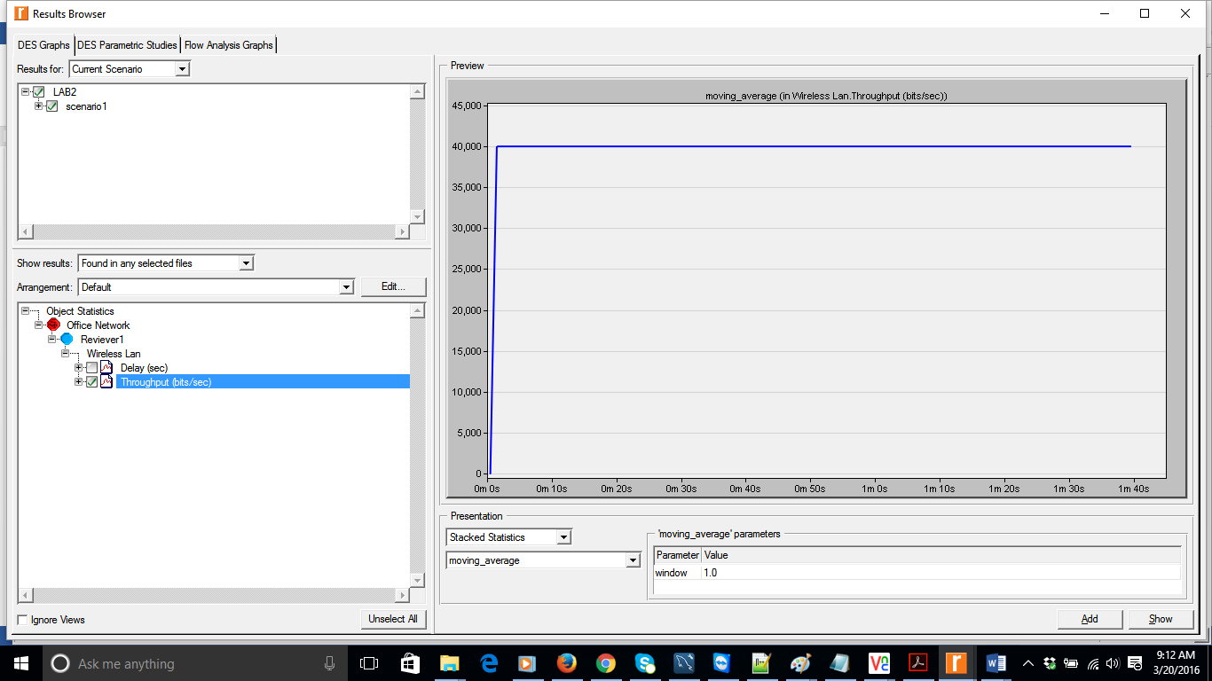

Access delay of an individual station with streaming video traffic.

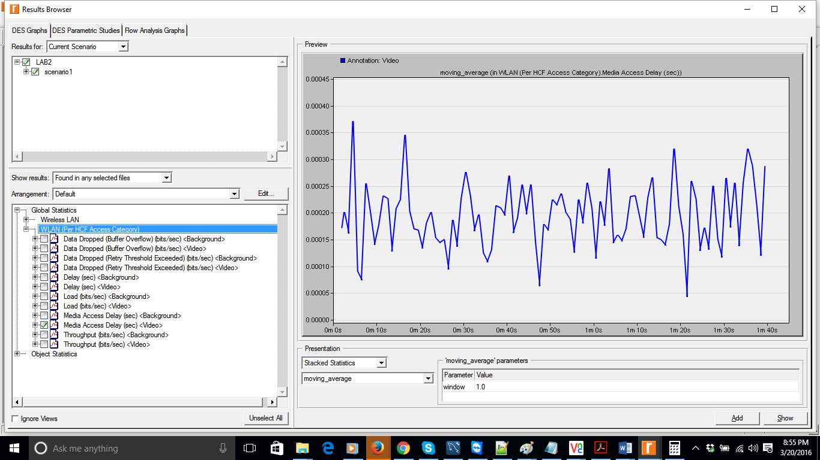

Throughput at Nodes 3, 4, 5 and 6 at Receiving Station2:

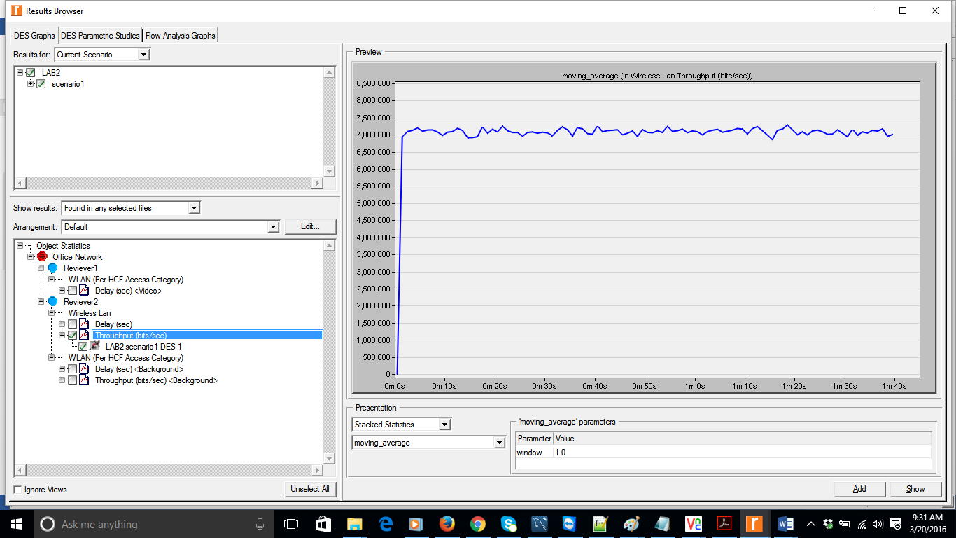

Access Delay at 2, 3, 4 & 5:

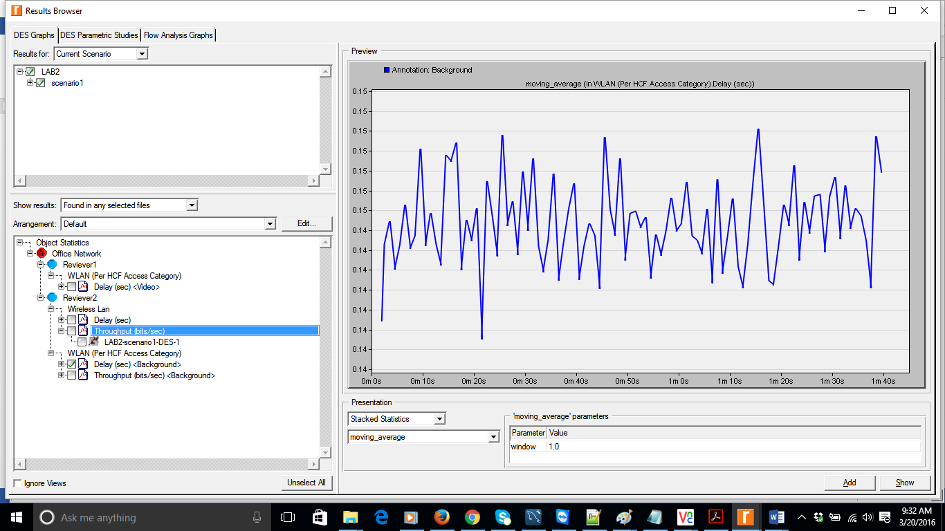

Answers:

1. Does the video traffic have higher priority over background traffic? How can you tell from the results?

Ans: Yes.

The graphs below leads us to infer that data dropped [buffer overflow] for video traffic is 0 and data dropped [buffer overflow] for background traffic is 150Mpbs. So video traffic has highest priority.

Data Dropped for Video Traffic: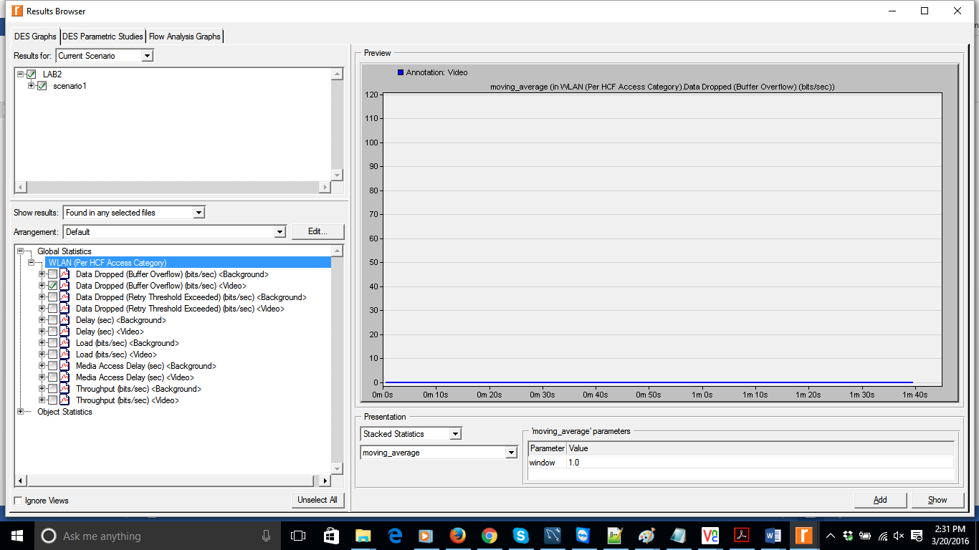

Data dropped for Background traffic:

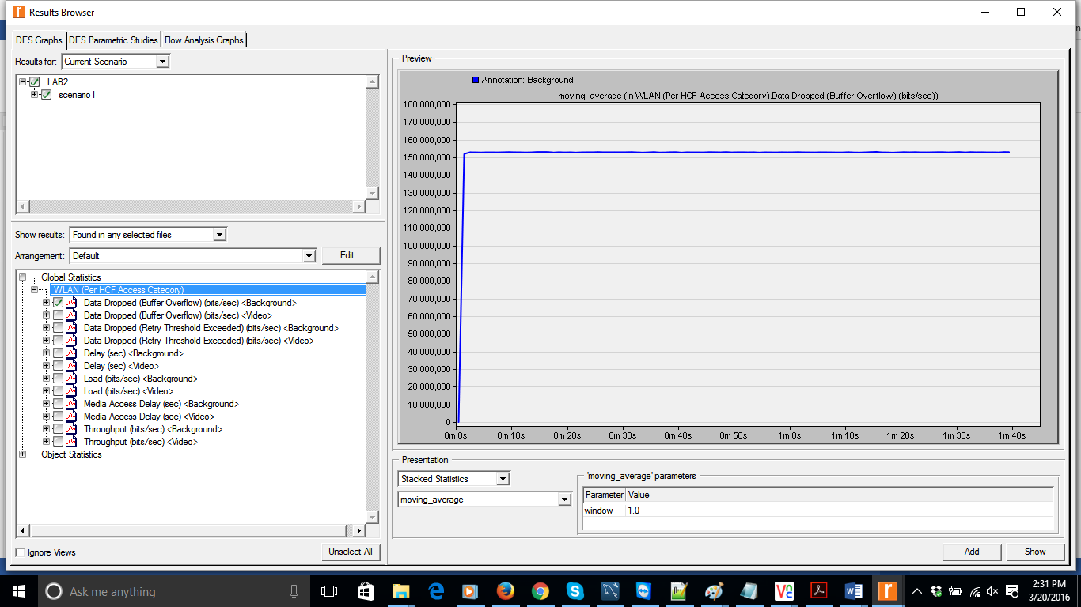

The global statistic media access delay video traffic is **0.00025** secondswhich is very less when compared to the media access delay for background traffic **0.14 s**econds indicates that the video traffic has priority.

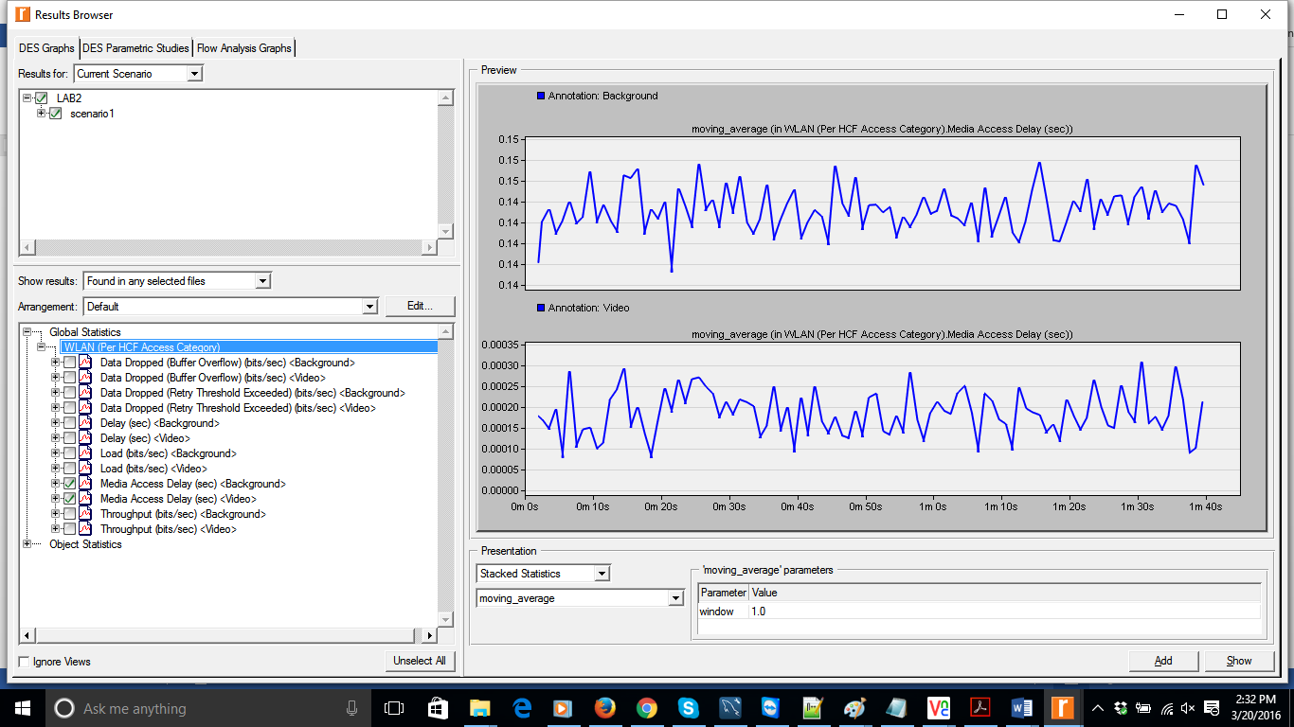

2) Is background traffic utilizing the bandwidth that is left by the video traffic in the network? How much bandwidth does a station with background traffic get on average?

Ans: Yes

The Video traffic bandwidth is (500 Byte Packet size, 0.1 Sec Interarrival time) = 0.04Mbps

The Background traffic bandwidth is 7Mbps

Total bandwidth is 7.04Mbps

An average Bandwidth for Background traffic is 7Mbps/4 = 1.75Mbps

We can see that background traffic is utilizing the bandwidth that is left by the video traffic in the network

Secanrio2

Set the video packet inter-arrival time to be 0.001s. Run the simulation and collect results.

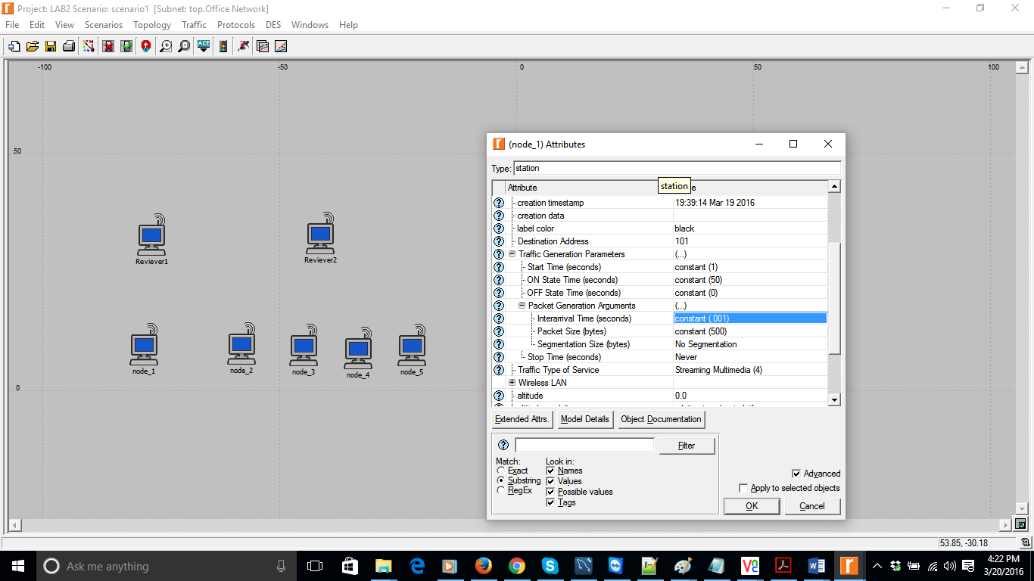

Throughput for Node1 at Receiving Station1 streaming video traffic: 4Mbps

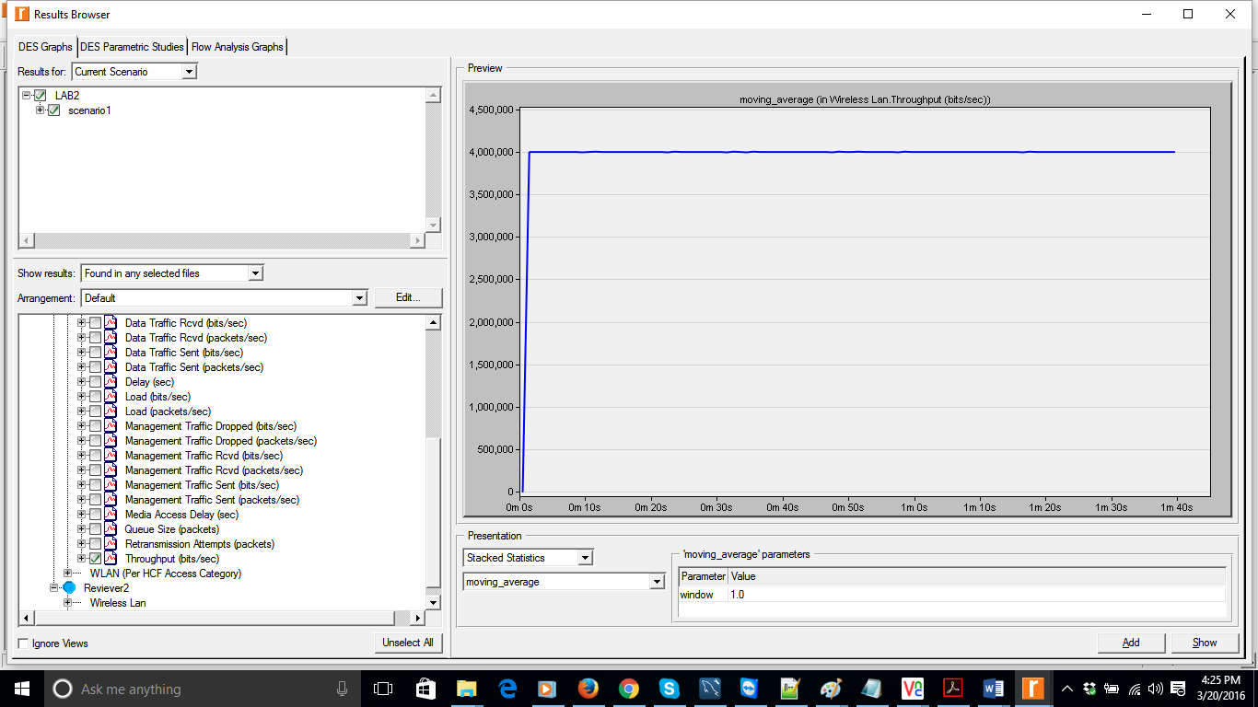

Access delay of an individual station with streaming video traffic.-0.00022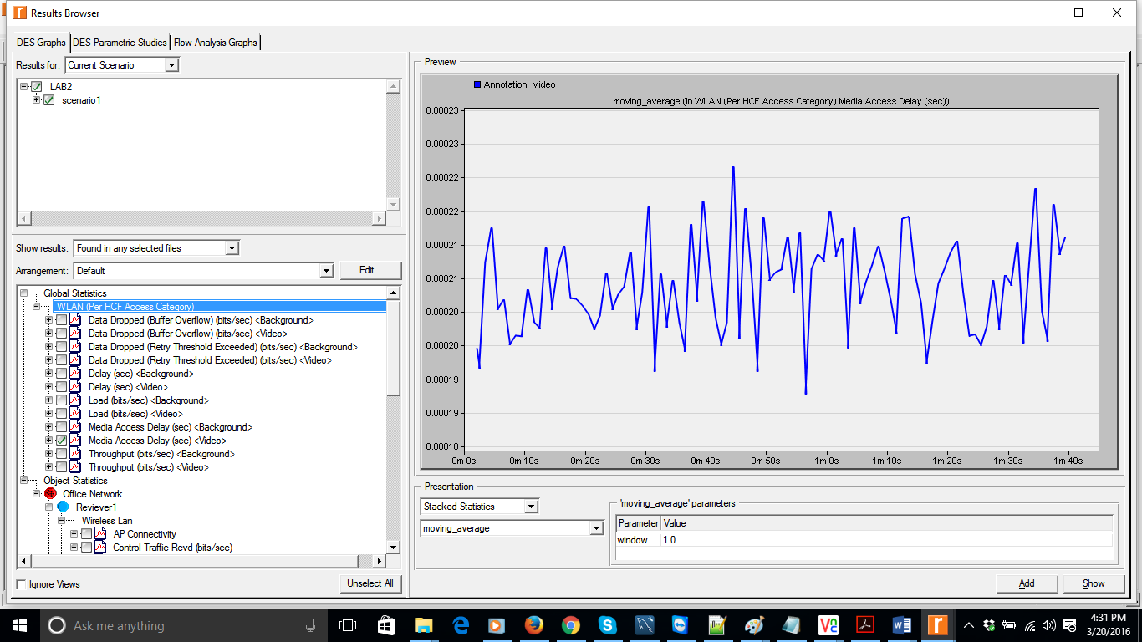

Throughput of background traffic: 4.5Mbps (Approx.)

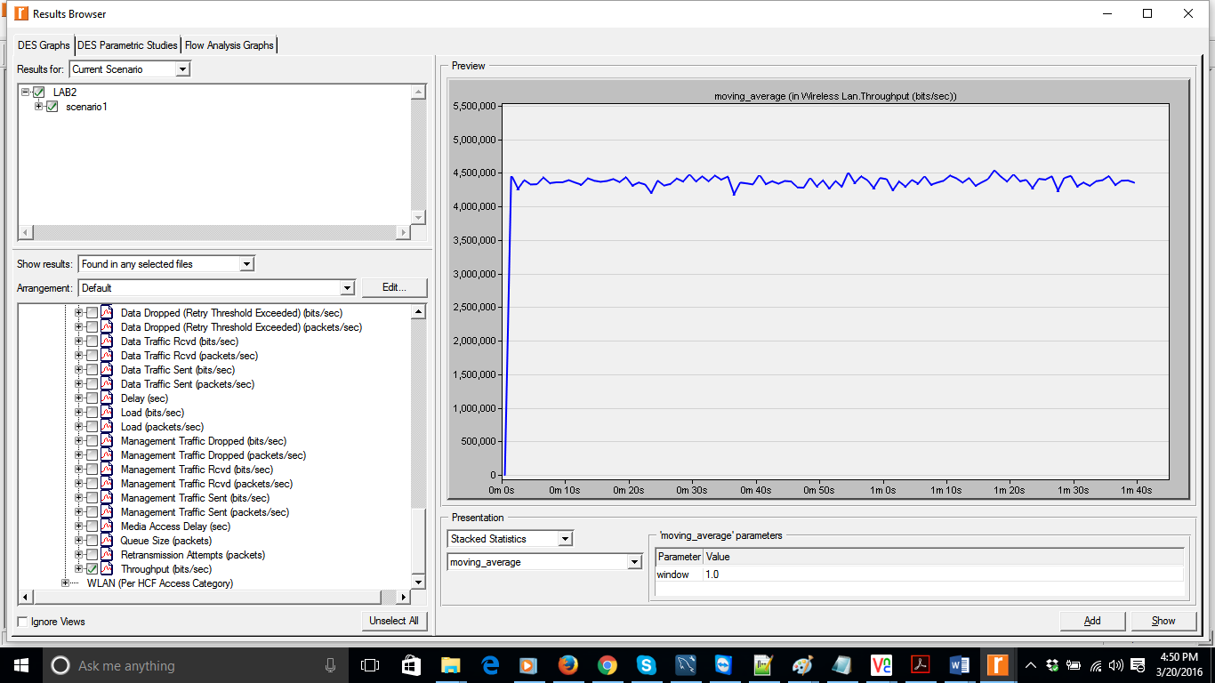

Access delay for Background traffic: 0.24

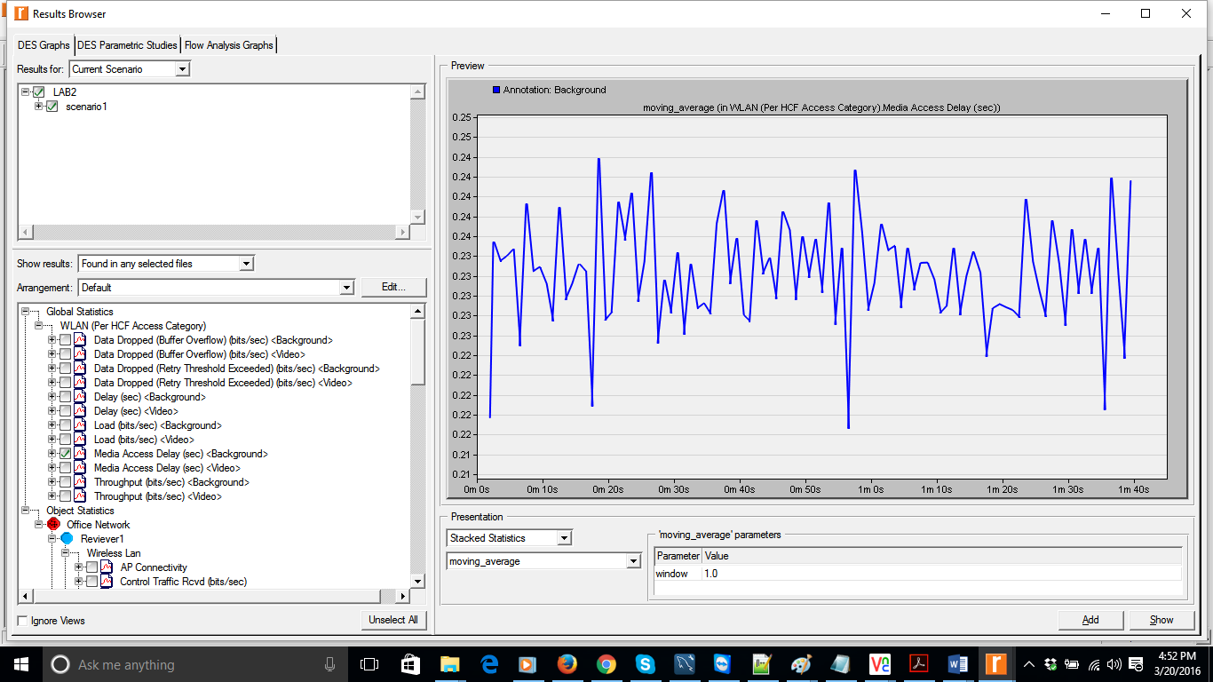

1) Does the video traffic have higher priority over background traffic? How can you tell from the results?

Ans: Yes.

From the graph we can infer that data dropped [buffer overflow] for video traffic is 0 and data dropped [buffer overflow] for background traffic is 150Mpbs. So video traffic has highest priority.

Data Dropped for Video Traffic:

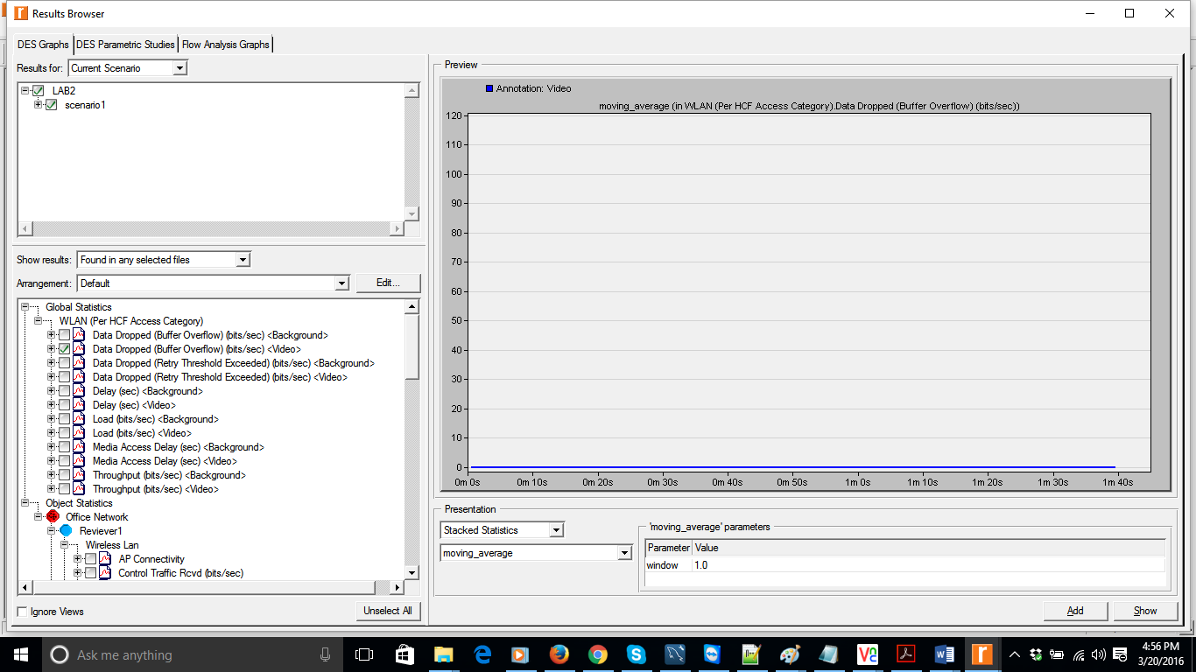

Data dropped for Background Traffic: 150 Mbps

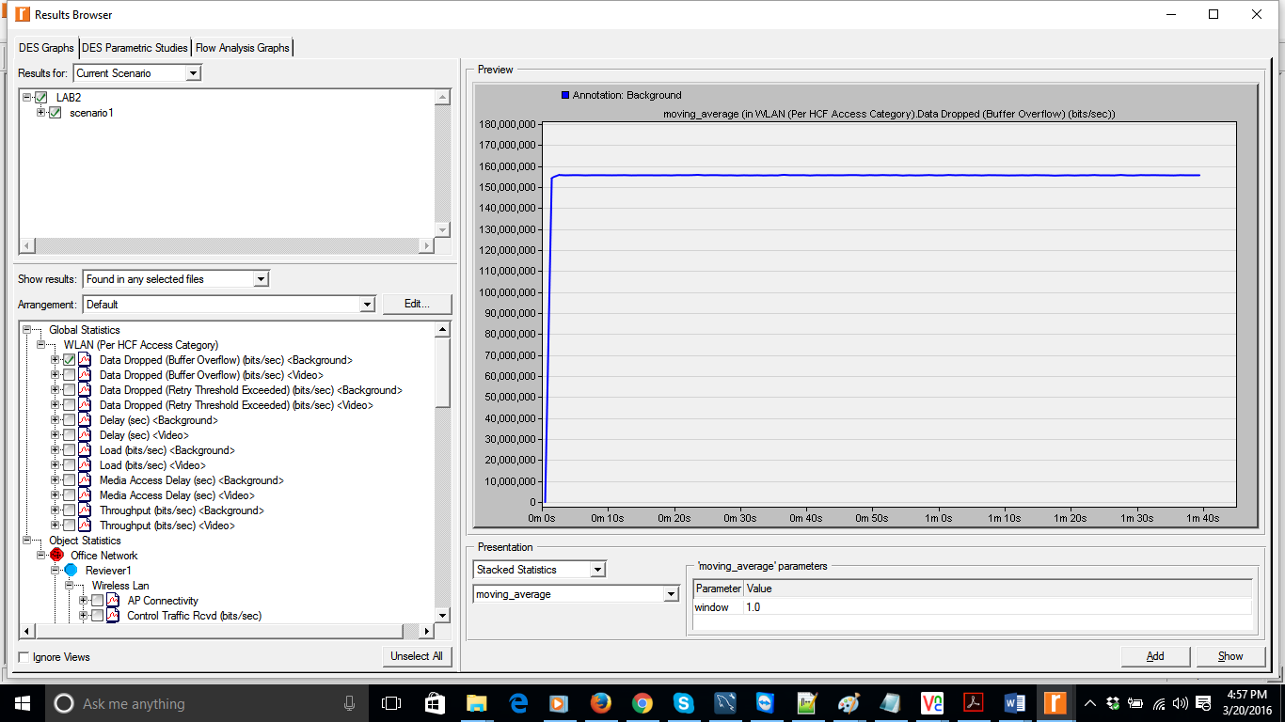

2) Is background traffic utilizing the bandwidth that is left by the video traffic in the network? How much bandwidth does a station with background traffic get on average?

Ans: Yes

For Video traffic Bandwidth is (500 Byte Packet size, 0.001 Sec Interarrival time) =4Mbps

Background traffic Bandwidth is 4.5Mbps

Overall Bandwidth is 8.5Mbps

Bandwidth for Background traffic is 4500000/4 = 1.125 Mbps

So we can see that background traffic is utilizing the bandwidth that is left by the video traffic in the network.

Overall throughput:

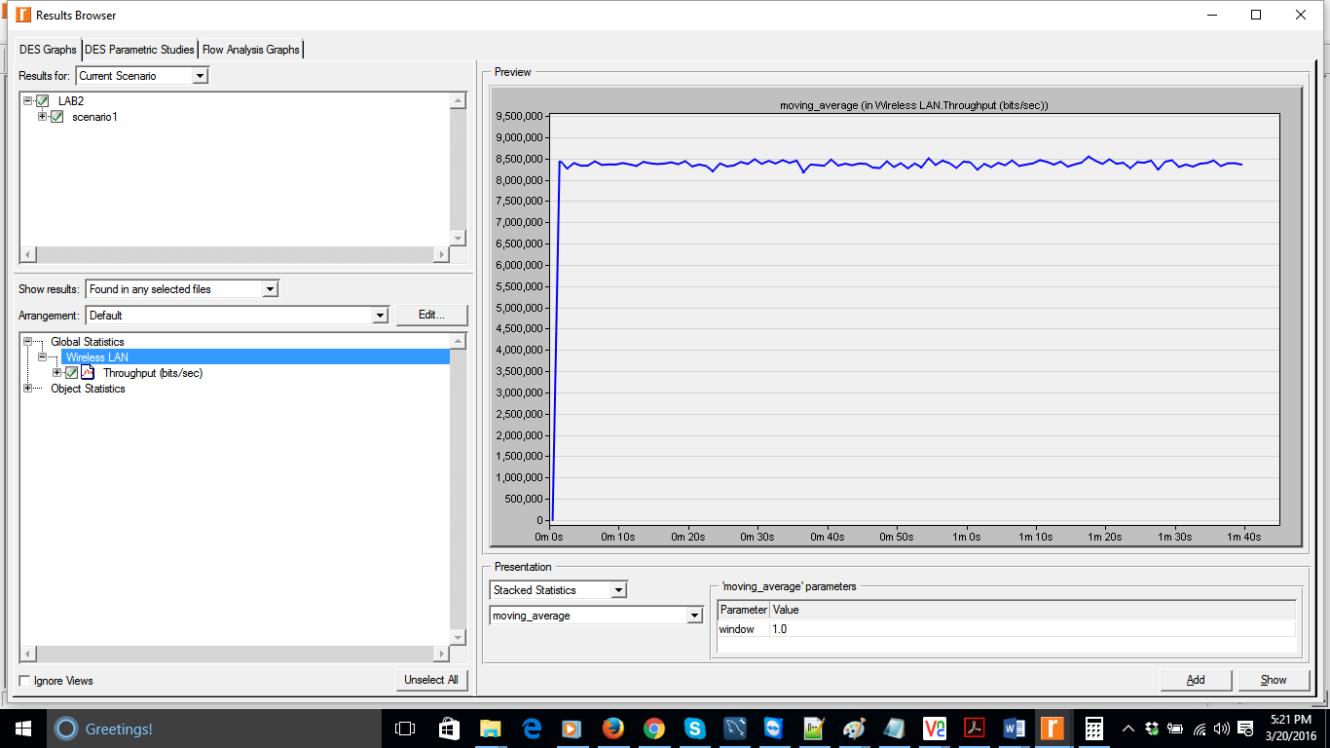

Scenario2: 10 Nodes where 3 nodes are sending video traffic with Interarrival time is 0.1 sec and all 7nodes sending background traffic with inter-arrival time is 0.0001sec

Video Traffic nodes configuration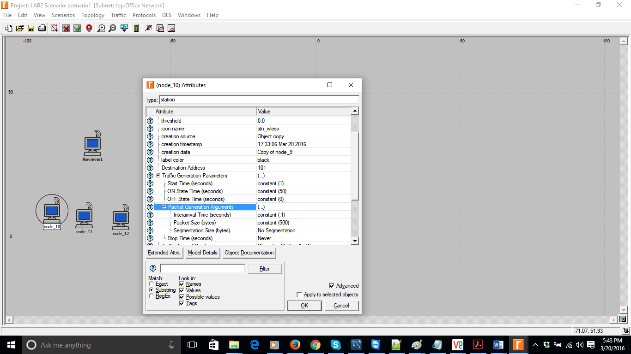

Back ground traffic node configuration

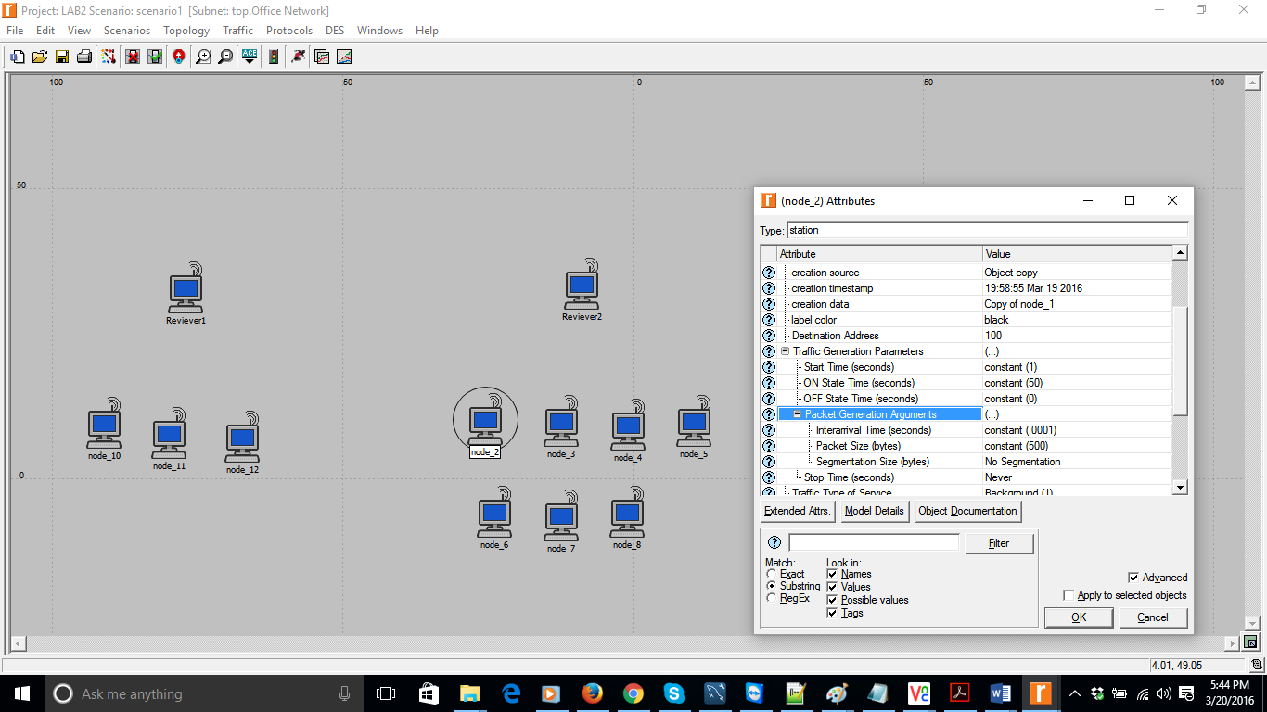

Throughput for Node1, 2 & 3 at Receiving Station1 streaming video traffic: 120000

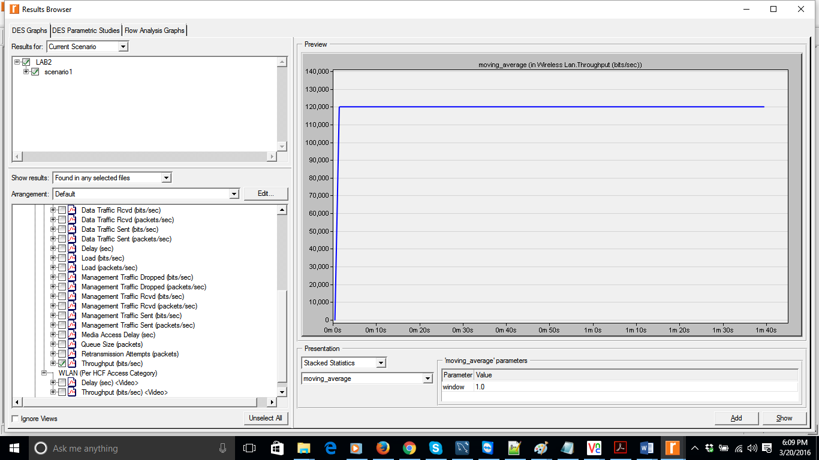

Access delay for Node1, 2 & 3 at Receiving Station1 streaming video traffic: 0.00055 Seconds

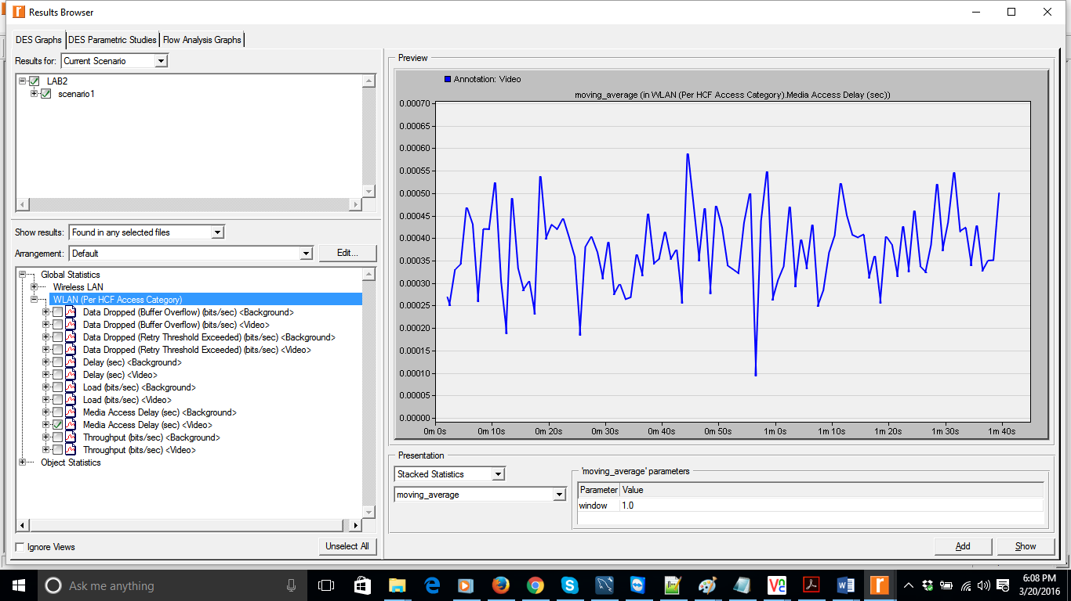

Throughput for Background Traffic [Nodes 5, 6, 7, 8, 9, 19, 11] At Receiver Station2 is 6.5 Mbps

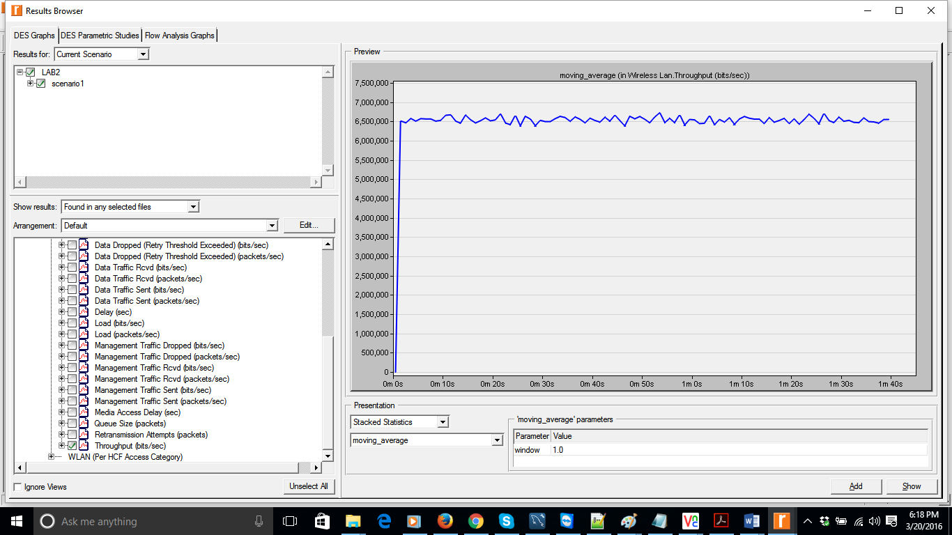

Access delay for Background Traffic [Nodes 4-10] At Receiver Station2 is 0.28 Seconds Approx.

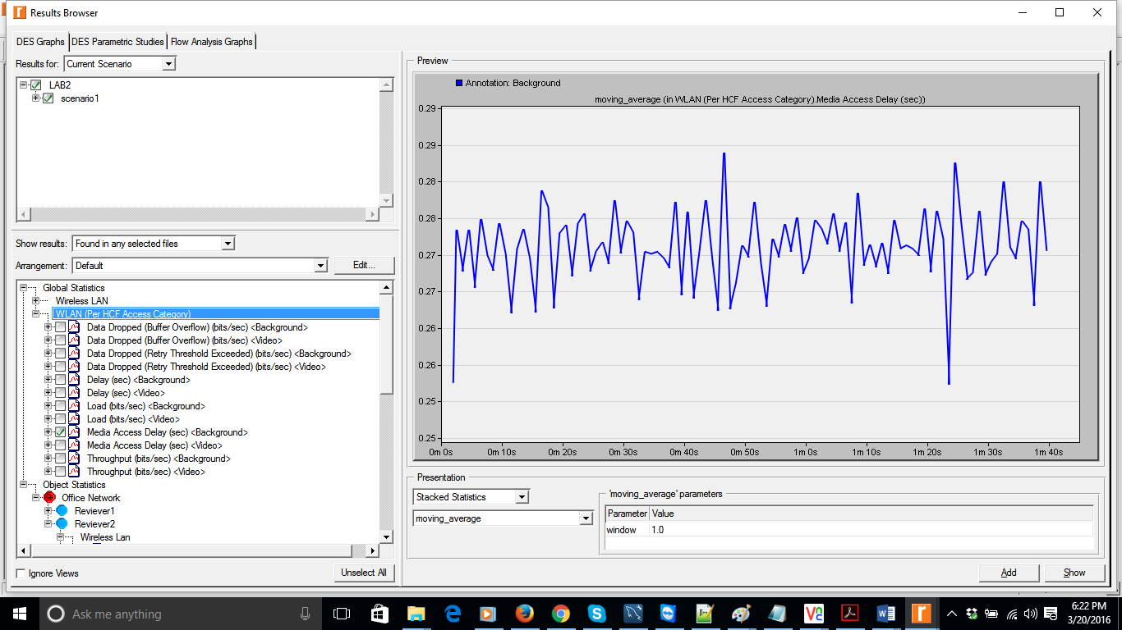

1) Does the video traffic have higher priority over background traffic? How can you tell from the results?

How can you tell from the results?

2) Is background traffic utilizing the bandwidth that is left by the video traffic in the network? How much bandwidth does a station with background traffic get on average?

Ans: Yes, the video traffic have higher priority.

From the graph below we can infer that data dropped [buffer overflow] for video traffic is 0 and data dropped [buffer overflow] for background traffic is 260Mpbs. So video traffic has highest priority

Buffer overflow for Video Traffic: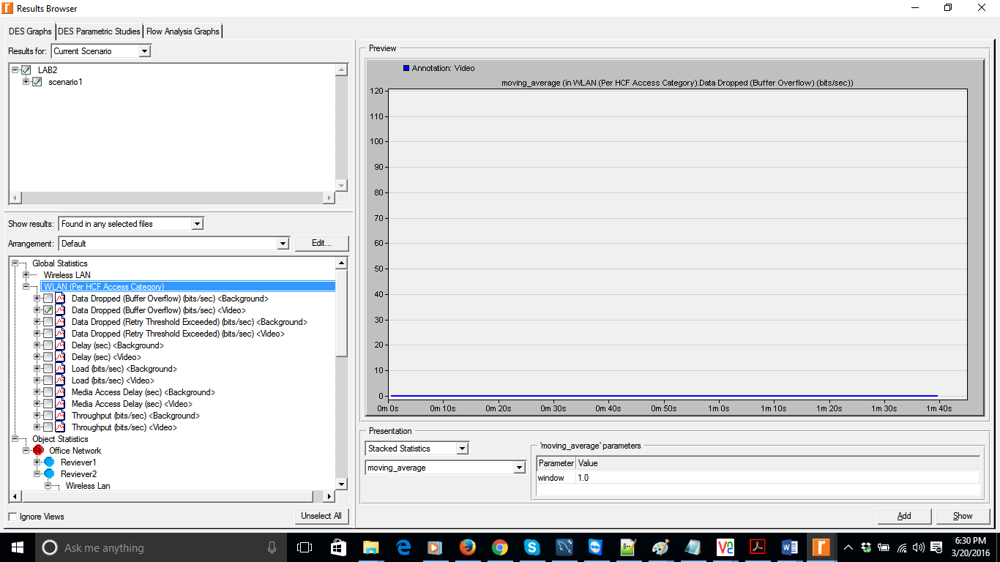

Buffer overflow for Background Traffic:

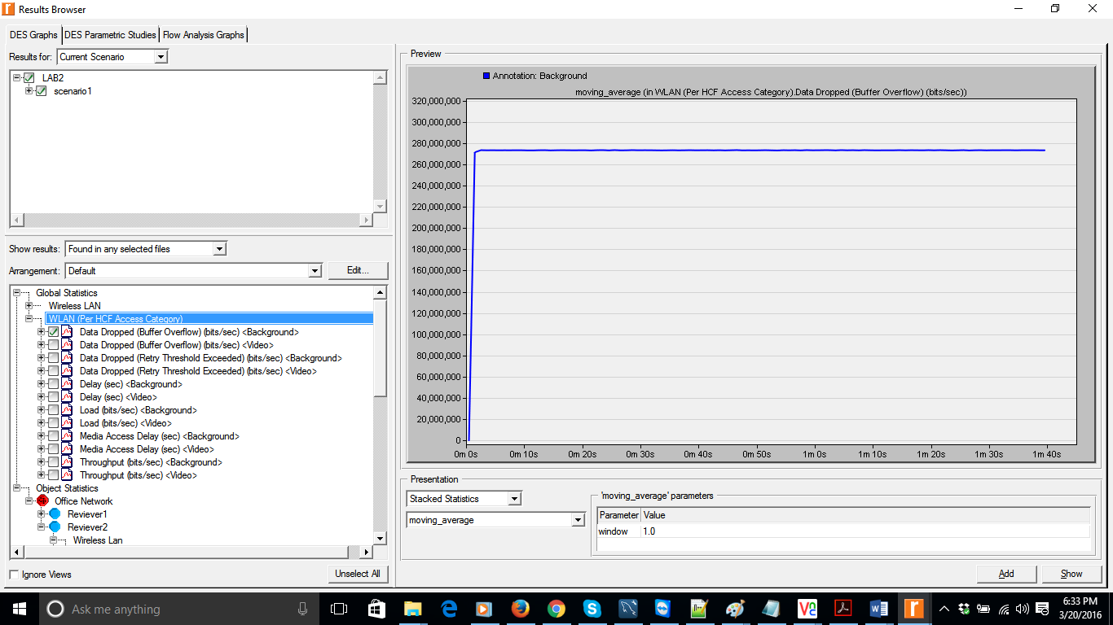

2) Is background traffic utilizing the bandwidth that is left by the video traffic in the network? How much bandwidth does a station with background traffic get on average?

Ans: Yes

For Video traffic Bandwidth is 0.12Mbps

Background traffic Bandwidth is 6.5Mbps

Overall Bandwidth is 6.67Mbps

Bandwidth for Background traffic on average is 6.5Mbps/7 = 0.928Mbps (Approx.)

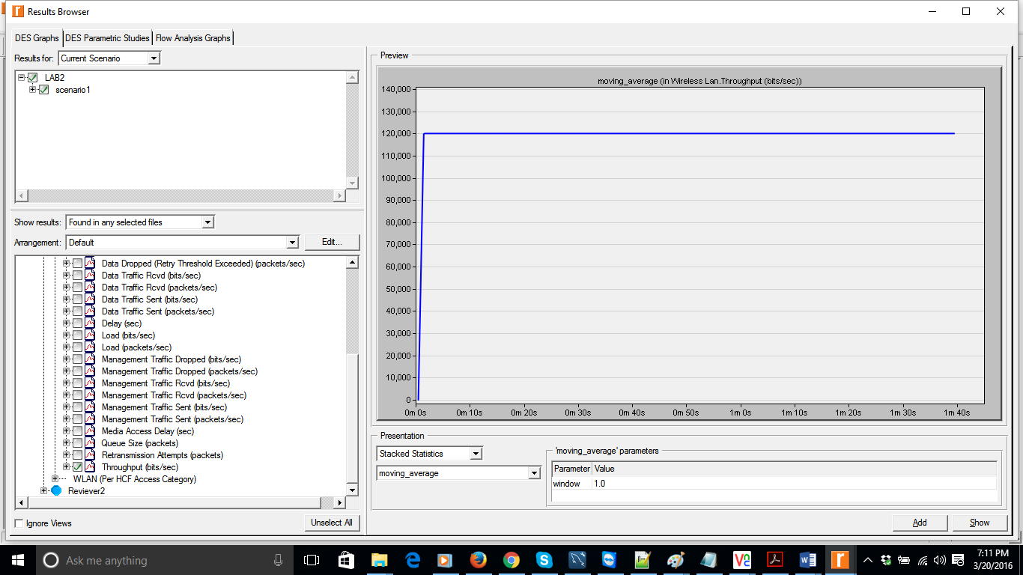

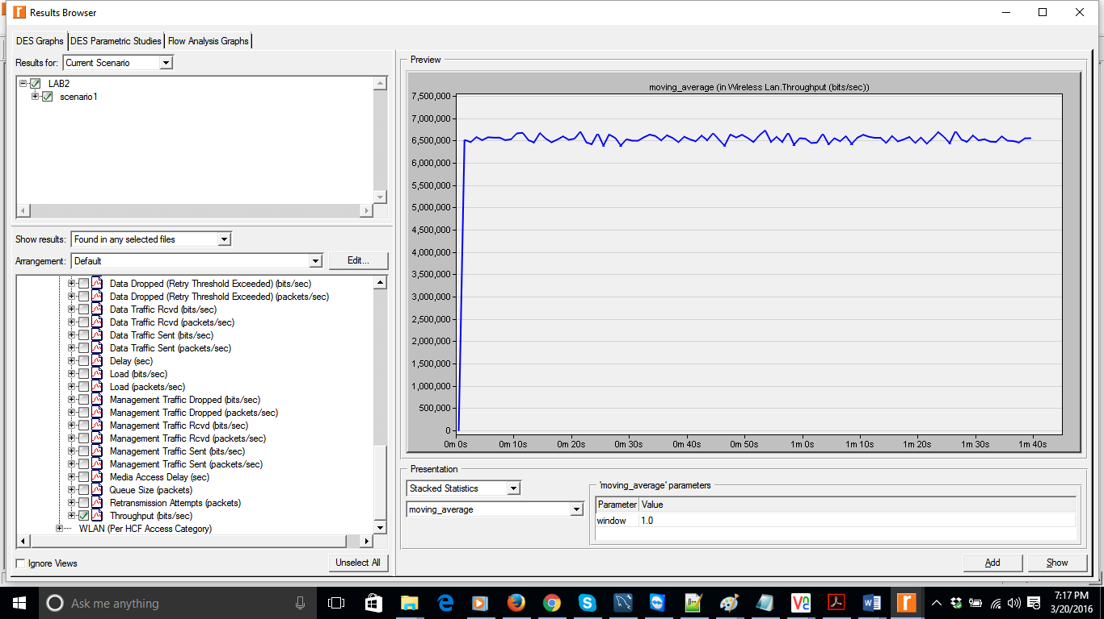

# Inter-Arrival time for Video Traffic=0.001sec

Network Topology & Configuration

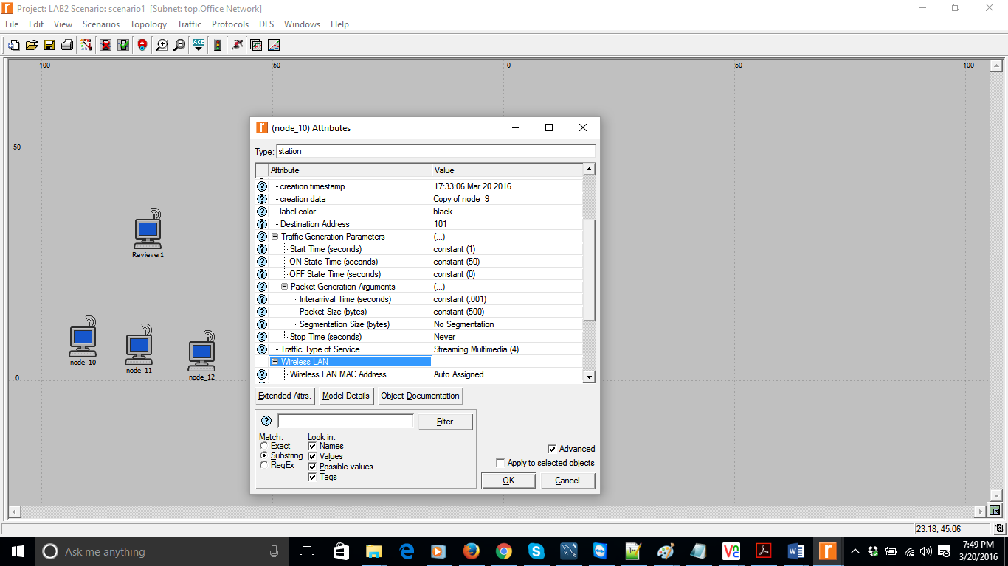

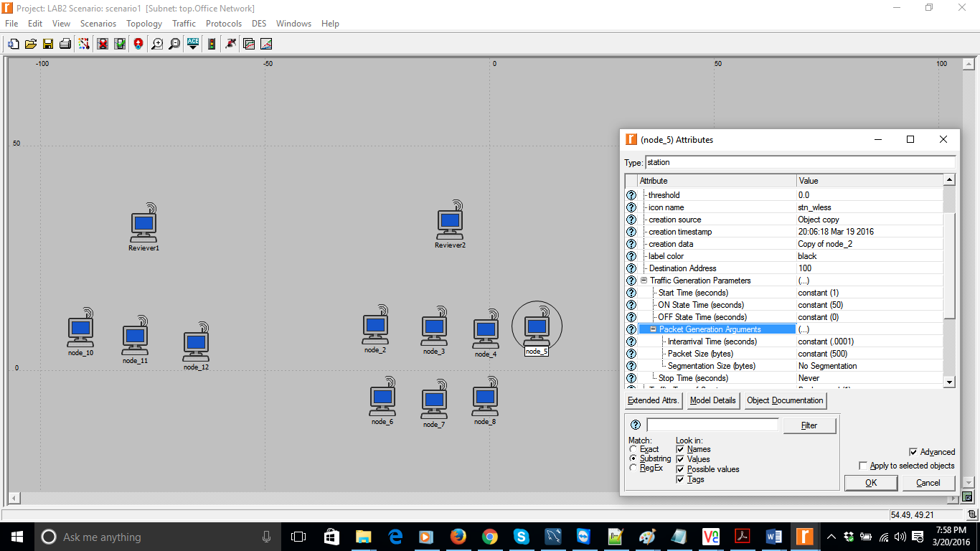

Throughput at Reciever1 for node1 to 3: 12 Mbps

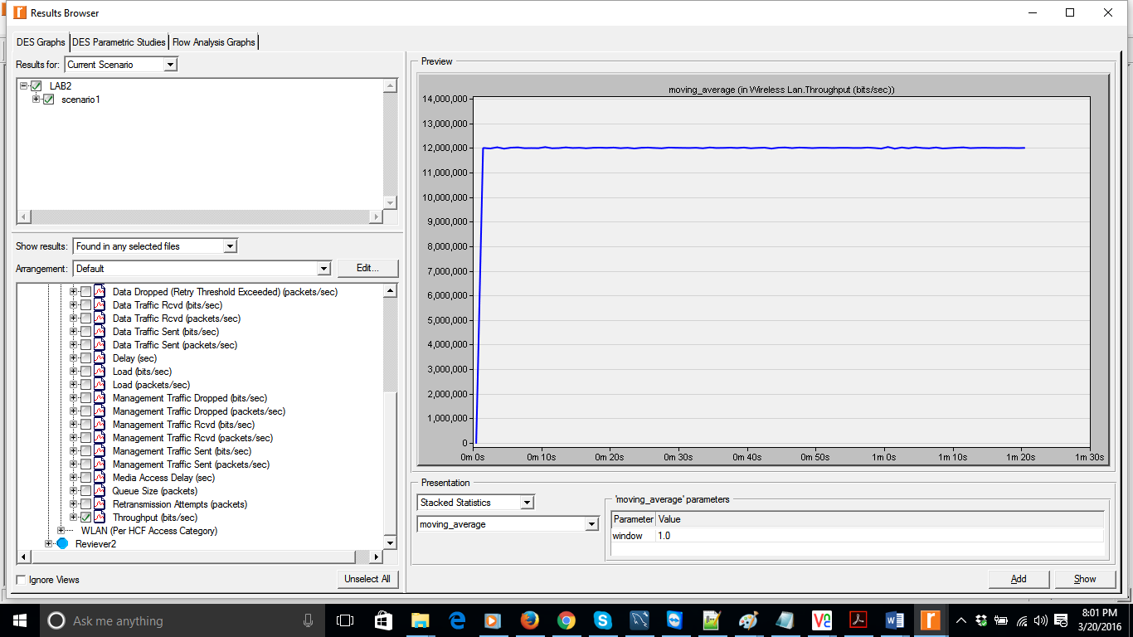

Throughput at receiving station2: 0.12 Mbps

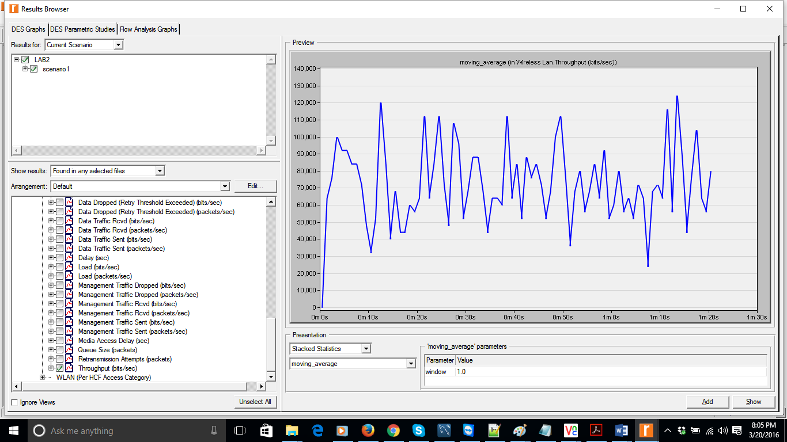

Media access delay for Video Traffic: 0.0020(Approx.)

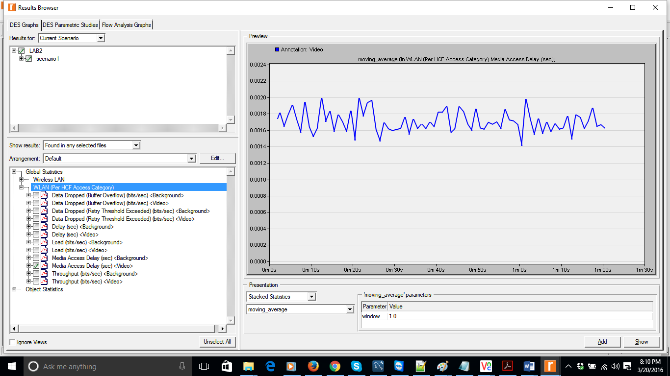

Media access delay for background Traffic: 30 Seconds

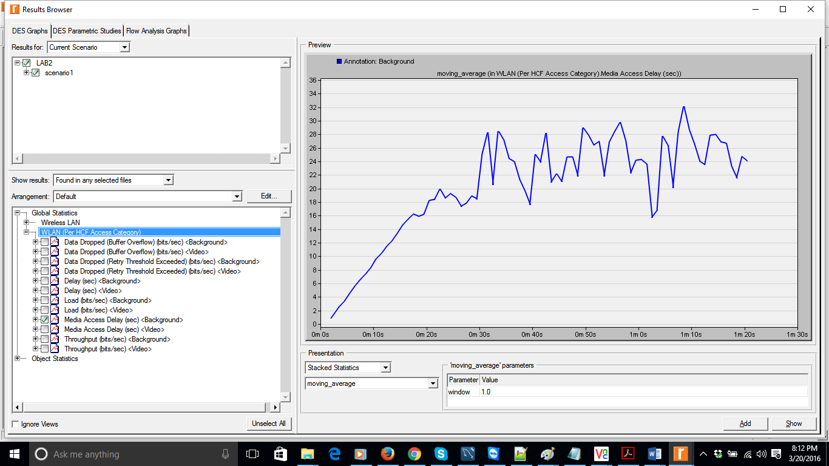

1. Does the video traffic have higher priority over background traffic? How can you tell from the results?

Ans: Yes

Buffer overflow for video traffic is 0 and for background traffic is 280Mbps.

The graphs (below) clearly indicate video traffic as having higher priority.

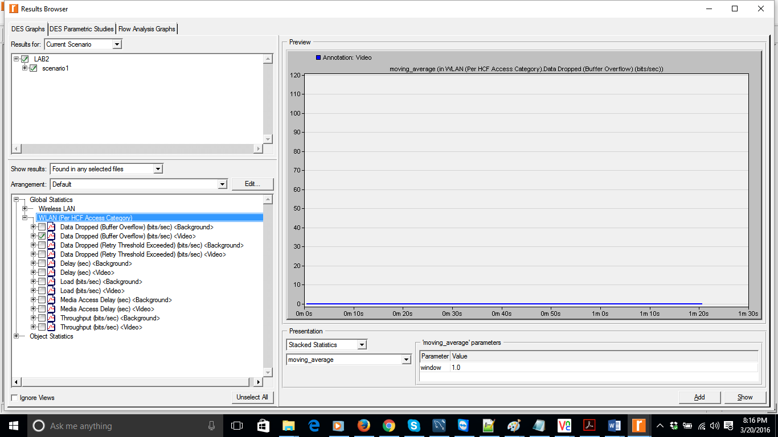

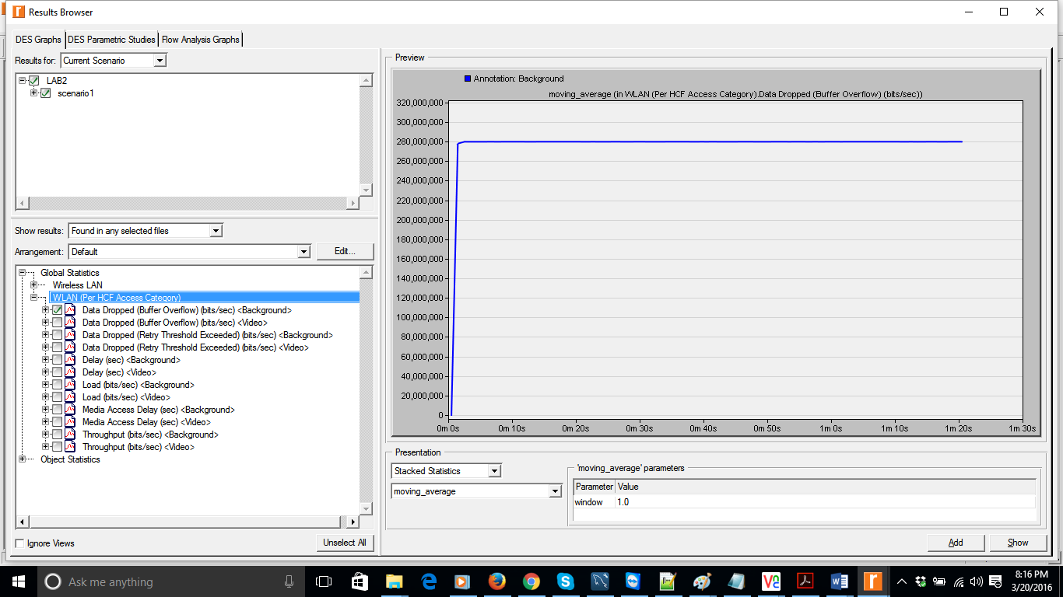

2) Is background traffic utilizing the bandwidth that is left by the video traffic in the network?

Ans: Yes

How much bandwidth does a station with background traffic get on average?

Bandwidth for video traffic is 12Mbps

Bandwidth for background traffic is 0.12 Mbps

Overall Bandwidth is 12.12Mbps

Since Video traffic as highest priority, background traffic will use the bandwidth left by video traffic.

Average background traffic is 120000/7= 0.0171Mbps

Overall Throughput:

